##### 

|  |  |
| --- | --- |
| Course Number | 1444 |
| Section Number | **1** |
| Course Title | MATHEMATICS FOR EMBEDDED SYSTEMS |
| Semester/Year | Summer/2019 |

|  |  |
| --- | --- |
| Instructor | **Mohsen Salahi** |

|  |  |
| --- | --- |
| **Lab No.** | **4** |

|  |  |
| --- | --- |
| Submission Date | **25/07/2019** |
| Due Date | **28/07/2019** |

|  |  |  |  |
| --- | --- | --- | --- |
| Student Name |  |  | **Jerin Joy** |
| Student ID |  |  | C0755173 |
| Signature* |  |  | **JJ** |

*\*By signing above you attest that you have contributed to this submission and confirm that all work you have contributed to this submission is your own work. Any suspicion of copying or plagiarism in this work will result in an investigation of Academic Misconduct and may result in a “0” on the work, an “F” in the course, or possibly more severe penalties.*

***Polynomial Interpolating Using Newton Form***

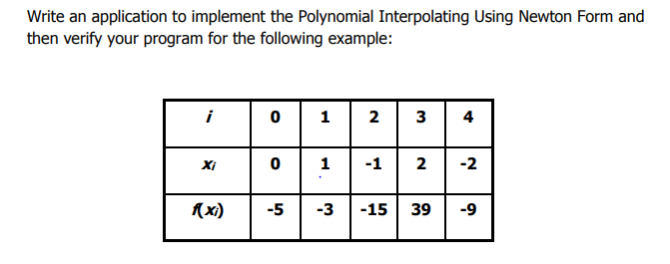

Program

#include <iostream>

#include <string>

using namespace std;

int main()

{

int m,i,j;

float x[20],f[20],a,sum=0,fact;

cout<<"No of functions given = ";

cin>>m;

cout<<" Value of Xi with corresponding f(Xi) ";

for(i=0;i<m;i++)

cin>>x[i]>>f[i];

cout<< " value of 't'= ";

cin>>a;

for(j=0;j<m-1;j++)

{

for(i=m-1;i>j;i--)

f[i]=(f[i]-f[i-1])/(x[i]-x[i-j-1]);

}

for(i=m-1;i>=0;i--)

{

fact=1;

for(j=0;j<i;j++)

fact*=(a-x[j]);

fact*=f[j];

sum+=fact;

}

cout<<"The value is "<<sum;

return 0;

}

Output:

